Design sketches offer first impression of new ŠKODA FABIA MONTE CARLO

- Fourth-generation FABIA continues the tradition of sporty lifestyle variants
- Sporty exterior with numerous black elements and unique MONTE CARLO skirts
- Sporty interior design with red accents and carbon-style elements

Mladá Boleslav, 2 February 2022 – ŠKODA AUTO has released several official design sketches, offering a first glimpse of the new FABIA MONTE CARLO. The sporty lifestyle variant made its debut eleven years ago in the second-generation FABIA. The signature black MONTE CARLO elements show off the fourth-generation FABIA’s considerably more emotive lines and dynamic proportions. Carbon-style elements and red decorative trim strips provide accents in the sporty interior.

The exterior sketch of the new ŠKODA FABIA MONTE CARLO shows how the signature details of this model version enhance the emotive design and dynamic appearance of the new FABIA. The frame of the ŠKODA grille features the same black finish as the spoiler lip on the exclusive front apron, which is characterised by a large air intake. The diffuser in the sporty rear apron and the lettering on the tailgate are also finished in black, as are the exterior mirror caps, the window frames, the side skirts and the rear spoiler; the wings feature MONTE CARLO badges.

The interior is predominantly black. The height-adjustable sports seats benefit from integrated headrests, while the 3-spoke multifunction sports steering wheel bears the MONTE CARLO badge. The leather trims for the steering wheel rim as well as the handbrake and gear stick feature black stitching. Stylish red accents appear on the seat covers and the horizontal dashboard trim, on the centre console and on the bold door handles. Carbon-style elements accentuate the armrests of the front doors and the lower part of the instrument panel.

Sporty ŠKODA lifestyle models have carried the MONTE CARLO designation since 2011. Their black body elements, sporty interior design and extended standard equipment recall ŠKODA’s successes at the legendary Monte Carlo Rally. ŠKODA introduced this equipment variant eleven years ago for the second-generation FABIA. Later, a MONTE CARLO version would also be produced for its successor as well as the CITIGO, the YETI and the RAPID SPACEBACK.
ŠKODA currently offers the SCALA MONTE CARLO and the KAMIQ MONTE CARLO and will soon be expanding the line-up to include the new fourth-generation FABIA.

Further information:
Liana Picard
PR Manager
T.: 02/260 24 01
M.: 0473 45 48 77
liana.picard@dieteren.be
www.skoda-press.be

Media images:

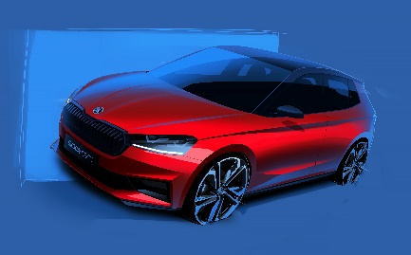 | Design sketches offer first impression of new  ŠKODA FABIA MONTE CARLO  The exterior sketch of the new ŠKODA FABIA  MONTE CARLO shows how the signature details of this model version enhance the emotive design and dynamic appearance of the new FABIA.  Download Source: ŠKODA AUTO
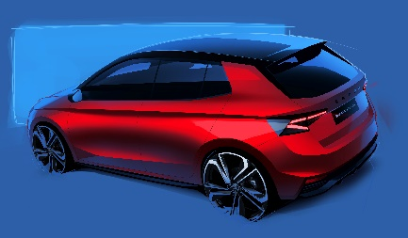 | Design sketches offer first impression of new  ŠKODA FABIA MONTE CARLO  The diffuser in the sporty rear apron and the lettering on the tailgate are finished in black, as are the exterior mirror caps, the window frames, the side skirts and the rear spoiler.  Download Source: ŠKODA AUTO
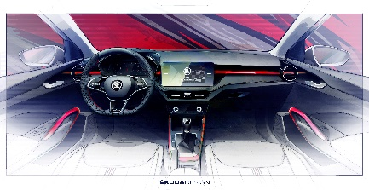 | Design sketches offer first impression of new  ŠKODA FABIA MONTE CARLO  The interior is predominantly black. The height-adjustable sports seats benefit from integrated headrests, while the 3-spoke multifunction sports steering wheel bears the MONTE CARLO badge.  Download Source: ŠKODA AUTO

ŠKODA AUTO
- is successfully steering through the new decade with the NEXT LEVEL – ŠKODA STRATEGY 2030.
- aims to be one of the five best-selling brands in Europe by 2030 with an attractive line-up in the entry-level segments and additional e-models.
- is emerging as the leading European brand in India, Russia and North Africa.
- currently offers its customers ten passenger-car series: the FABIA, RAPID, SCALA, OCTAVIA and SUPERB as well as the KAMIQ, KAROQ, KODIAQ, ENYAQ iV and KUSHAQ.
- delivered over 870,000 vehicles to customers around the world in 2021.
- has been a member of the Volkswagen Group for 30 years. The Volkswagen Group is one of the most successful vehicle manufacturers in the world.
- independently manufactures and develops not only vehicles but also components such as engines and transmissions in association with the Group.
- operates at three sites in the Czech Republic; manufactures in China, Russia, Slovakia and India primarily through Group partnerships, as well as in Ukraine with a local partner.
- employs around 43,000 people globally and is active in over 100 markets.

